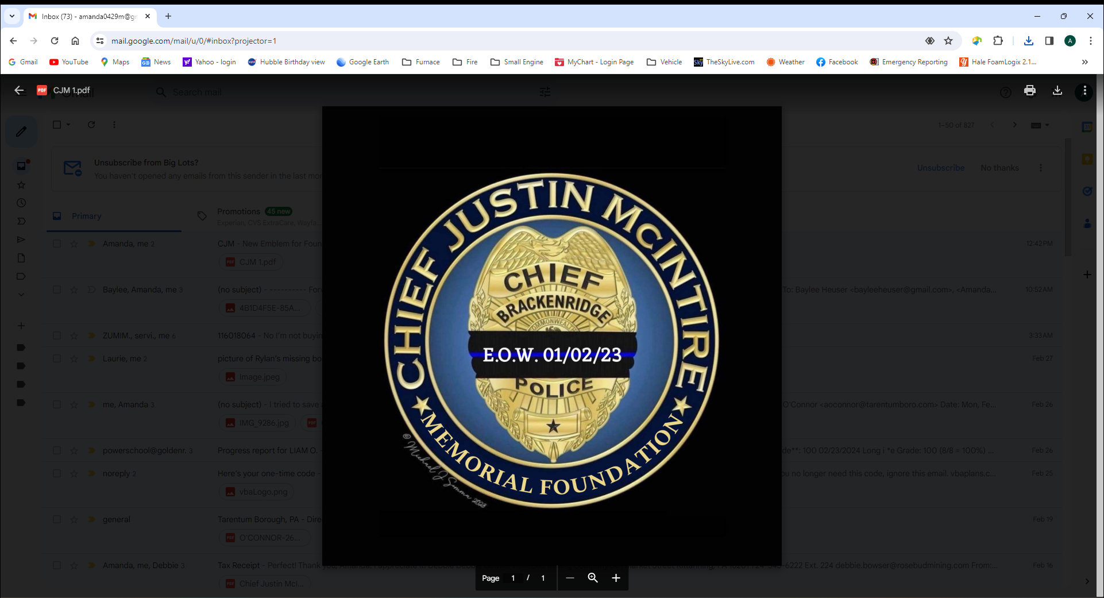
Chief Justin McIntire Memorial Foundation Cornhole Tournament Registration Form:
Payment is required up front to register:
Forms and payment are due by August 24, 2024
Registration Includes:
General Admission
Event T-Shirt

Name 1:_______________________________________________________

T-Shirt Size (Please circle one): S M L XL 2XL 3XL 4XL 5XL

Name 2:_______________________________________________________

T-Shirt Size (Please circle one): S M L XL 2XL 3XL 4XL 5XL

Team Name:___________________________________________________

Contact Phone Number: _______________________________________

$35.00 per person = $70 per team

Forms can be printed from the website and emailed back to CJM1501foundation@gmail.com
Payments can be completed via the secure website at:
chief-justin-mcintire-memorial-foundation.com
or
a check or money with registration forms can be made out to and mailed:
Chief Justin McIntire Memorial Foundation
1014 Atlantic Avenue
Brackenridge, PA 15014

