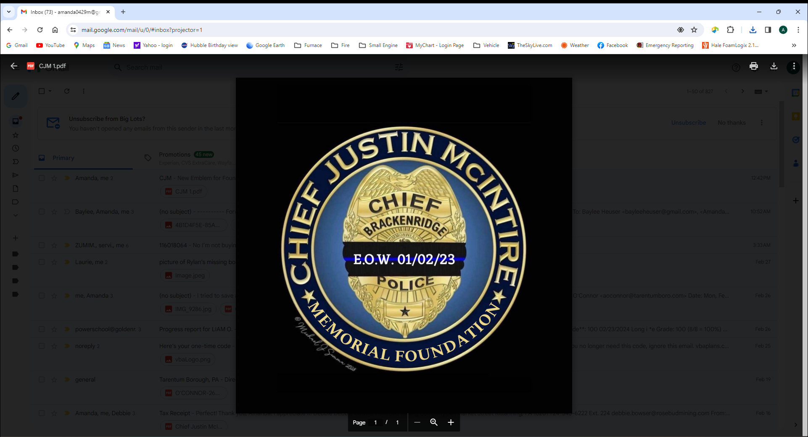

CHIEF JUSTIN MCINTIRE MEMORIAL FOUNDATION
2024 SPONSORSHIP FORM

BUSINESS NAME______________________________________

ADDRESS__________________________________

CONTACT NAME______________________________________

PHONE NUMBER _____________________________________

I WISH TO PARTICIPATE IN THE CHIEF JUSTIN MCINTIRE MEMORIAL FOUNDATION AS A:

_______ - T – SHIRT SPONSOR ($125.00)

_______ - RED SPONSOR ($250.00)

_______ - BLUE SPONSOR ($500.00)

_______ - OTHER – I WISH TO DONATE THE FOLLOWING AMOUNT TO THE
CHIEF JUSTIN MCINTIRE MEMORIAL FOUNDATION. $___________

_________ - I WISH TO DONATE A GIFT BASKET FOR THE BASKET RAFFLE TO BE HELD AT
THE CHIEF JUSTIN MCINTIRE MEMORIAL FOUNDATION EVENT. (CONTACT Amanda 724-980-1367)

PLEASE MAKE CHECK PAYABLE TO AND MAIL FORM TO:
CHIEF JUSTIN MCINTIRE MEMORIAL FOUNDATION
1014 ATLANTIC AVE
BRACKENRIDGE, PA 15014

YOU CAN ALSO MAKE A SECURE CREDIT CARD PAYMENT ON OUR WEBSITE AT:
WWW.CHIEF-JUSTIN-MCINTIRE-MEMORIAL-FOUNDATION.COM
EMAIL - CJM1501FOUNDATION@GMAIL.COM
FACEBOOK – CHIEF JUSTIN MCINTIRE MEMORIAL FOUNDATION

THE CHIEF JUSTIN MCINTIRE MEMORIAL FOUNDATION IS A TAX-EXEMPT 501(C)3 CHARITABLE ORGANIZATION. FEDERAL TAX INFORMATION IS AVAILABLE UPON REQUEST.

